**Team Name :** BitMasters

**Project Title :** Safezone : Real-time Video Analytics for Industrial Safety

## 1. Introduction

#### 1.1 Overview

The SafeZone project represents a cutting-edge fusion of technology and safety, aiming to revolutionise workplace security in industrial environments. This real-time video analytics web application harnesses the capabilities of Flask, YOLO, HTML, CSS, JavaScript, Bootstrap, OpenCV, and IBM Watson Assistant to detect and mitigate potential hazards in real-time. SafeZone offers a comprehensive solution to address safety concerns through proactive hazard identification, immediate alerts, and interactive communication.

#### 1.2 Purpose

The SafeZone project serves a critical purpose in ensuring the safety and well-being of individuals working in industrial environments. It aims to achieve the following objectives:

* **Real-time Hazard Detection:** By employing computer vision techniques powered by the YOLO model, SafeZone can instantly identify hazardous situations, including the presence of weapons, fall incidents, and unauthorized access.
* **Preventive Safety Measures:** SafeZone shifts the focus from reactive safety measures to proactive prevention. By detecting hazards as they occur, the project enables swift responses and preventive actions to mitigate risks.
* **Interactive Communication:** The integration of IBM Watson Assistant enhances user engagement and understanding. Through the chatbot, users can access immediate assistance, guidance, and clarification regarding safety alerts.
* **Comprehensive Workplace Security:** SafeZone's holistic approach to hazard detection ensures that a wide range of potential threats is identified, ranging from dangerous activities to unauthorized individuals.
* **Efficient Incident Management:** In the event of a detected hazard, SafeZone's email alert mechanism provides users with actionable information, such as images or videos, enabling quick and effective incident management.

SafeZone contributes to a safer working environment by leveraging technology to augment human vigilance, reduce response times, and empower organizations to take pre-emptive actions against potential safety risks.

## 2. LITERATURE SURVEY

#### 2.1 Existing Problem

Industrial safety has been a persistent concern across diverse sectors, where the interplay of complex processes, heavy machinery, and human interaction necessitates vigilant hazard monitoring. Traditional safety protocols have often relied on manual observation and periodic checks, which can lead to delayed responses and increased risks. The dynamic nature of industrial environments, coupled with the potential for human error, further exacerbates the challenge of timely hazard identification.

In industries such as manufacturing, construction, energy, and transportation, the consequences of inadequate safety measures can range from personal injuries to massive financial losses. Moreover, ensuring the safety of employees, assets, and the surrounding environment is not solely a regulatory obligation but also a moral and ethical responsibility.

#### 2.2 Proposed Solution

The SafeZone project addresses these challenges through the integration of advanced technologies to create a real-time video analytics web app for hazard detection and prevention. Leveraging Flask, YOLO model, IBM Watson Assistant, and more, the proposed solution aims to revolutionise the way industrial safety is managed.

By training the YOLO model on specific hazard classes—weapon detection, fall detection, and robber-mask detection—the system achieves accurate identification of potential threats. The user-friendly web interface allows stakeholders to upload images and videos for hazard detection. This interface is supported by OpenCV and AI technologies, which enable quick and precise analysis.

IBM Watson Assistant's chatbot integration further enhances user interaction, providing real-time support within the web app. The system's proactive identification of objects and behaviours empowers swift responses, reducing accidents and damage.

The proactive nature of the SafeZone system ensures that objects, activities, and behaviours of interest are promptly identified. This approach not only prevents accidents but also contributes to the overall efficiency and productivity of industrial operations.

## 3. THEORITICALANALYSIS

#### 3.1 Block Diagram

The block diagram shows the interaction between a user and our proposed solution. The user first uploads an image or video to the system using the User Interface. The system then uses the YOLO AI Model to detect unsafe conditions in the image or video. If an unsafe condition is detected, the system will send an alert to the user via **Email** Messaging Service.

The user can also request help from an IBM Watson Assistant if they need assistance.

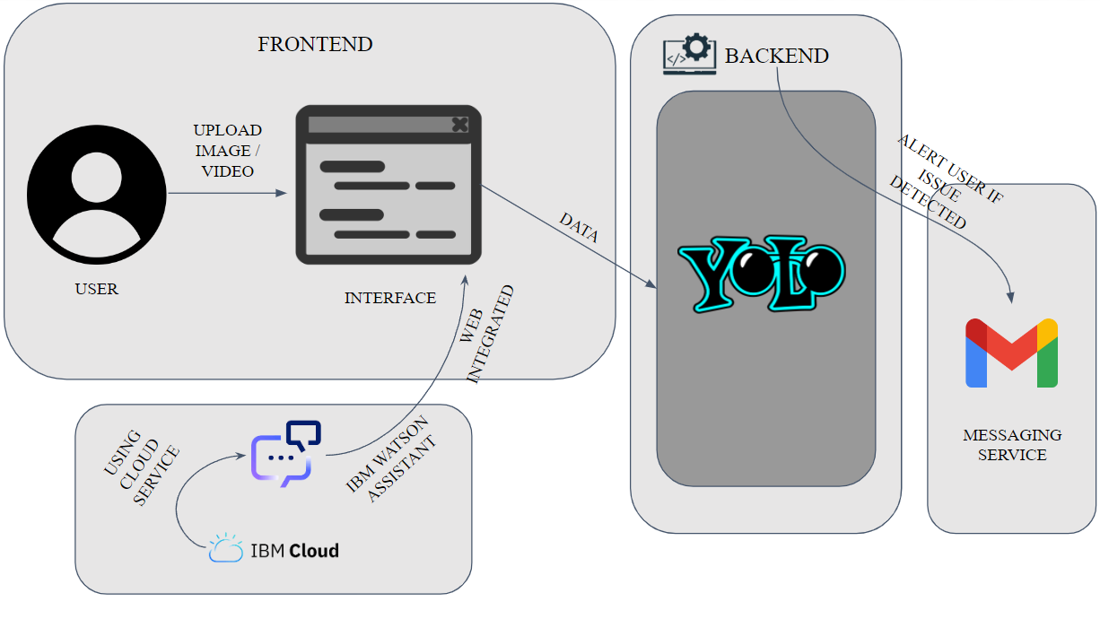

* **User Interface:** The user interface is the part of the system that the user interacts with. It allows the user to upload images or videos, request unsafe condition detection, and view the results of the detection.
* **YOLO AI Model:** The YOLO AI Model is a computer vision model that can be used to detect objects in images or videos. It is trained on a dataset of images that contain unsafe conditions.
* **IBM Watson Assistant:** The IBM Watson Assistant is a chatbot that can be used to answer questions and provide assistance to users.
* **Email Messaging Service**: The messaging service is used to send alerts to the user. The alert will include the details of the unsafe condition, such as the type of condition, the location of the condition, and the time the condition was detected.

#### 3.2 Hardware and software requirements

**3.2.1 Hardware Requirements**

The SafeZone real-time video analytics web app involves a combination of hardware components to facilitate its operation. The primary hardware requirements include:

1. **Cameras:** High-quality cameras capable of capturing clear images and videos are essential for accurate hazard detection. The choice of cameras depends on the specific use case and environmental conditions.
2. **GPU:** The backend processing of image and video data, as well as the execution of the YOLO model, requires good GPU. This can be achieved through local servers or cloud-based infrastructure, such as AWS, Azure, or Google Cloud.
3. **Computer Resources:** For development and testing purposes, a computer with sufficient processing power, memory, and storage is required. This system will be used to develop, debug, and test the solution before deployment.

**3.2.2 Software Requirements**

The SafeZone project relies on a suite of software components to ensure seamless operation and interaction. The software requirements encompass various layers of the solution:

1. **Python:** The project is primarily developed using Python due to its versatility and compatibility with the required libraries and frameworks.
2. **Flask:** A web application framework is essential for creating the user-friendly interface. Flask's capabilities in handling requests, managing sessions, and rendering templates are utilised.
3. **OpenCV:** OpenCV is utilised for image and video processing tasks. Its extensive functionalities enable real-time analysis of uploaded media.
4. **YOLOv8:** YOLOv8 Model is used for identifying potential issue.
5. **IBM Watson Assistant:** To integrate the chatbot, the IBM Watson Assistant is employed. It allows for easy interaction between the web app and the chatbot service.
6. **Web Technologies:** HTML, CSS, JavaScript, and Bootstrap are utilised for creating the user interface. These technologies ensure responsive design and an intuitive user experience.
7. **Text Editors or Integrated Development Environments (IDEs):** Software such as Visual Studio Code, PyCharm, or Jupyter Notebook are used for coding, debugging, and running the project.

**3.2.3 System Architecture**

The project's system architecture involves a client-server model where clients (users) interact with the web app interface hosted on a server or cloud infrastructure. Images and videos uploaded by users are processed by the backend, which includes the YOLO model for hazard detection and the chatbot integration powered by IBM Watson Assistant.

## 4. EXPERIMENTAL INVESTIGATIONS

The development of the SafeZone real-time video analytics web app involved a comprehensive analysis of various components, technologies, and methodologies to create an effective and reliable solution for industrial safety. The investigation encompassed aspects ranging from model training to user experience design.

YOLO Model Selection and Training

An in-depth analysis of object detection models led to the selection of YOLO (You Only Look Once) as the foundation of the solution. The YOLOv3 architecture was chosen for its balance between accuracy and speed. Extensive research was conducted to understand the intricacies of model architecture, anchor box selection, and training parameters.

The training dataset was carefully curated, consisting of labelled images and videos for weapon detection, fall detection, and robber-mask detection classes. Analysis of the dataset distribution and augmentation techniques contributed to improving the model's robustness and generalisation.

User Interface Design

The analysis of user requirements and expectations played a crucial role in designing an intuitive web interface. Extensive user research was conducted to identify key features and functionalities that would enhance user interaction. Wireframes and prototypes were developed and iteratively refined based on user feedback.

The user interface analysis included considerations for responsive design, ease of media upload, real-time feedback, and integration of the IBM Watson Assistant chatbot. User-centric design principles guided the layout, color scheme, and information architecture of the interface.

Integration of Technologies

A comprehensive analysis of integration techniques was performed to seamlessly merge diverse technologies, including Flask, YOLO, OpenCV, and IBM Watson Assistant. Compatibility and interoperability were key factors, ensuring smooth data flow and communication between components.

The analysis of deployment options—local server vs. cloud-based—considered factors such as scalability, latency, and resource utilization. This analysis influenced the decision to deploy the web app on a cloud platform for broader accessibility and potential scalability.

Performance and Accuracy Assessment

Throughout development, continuous analysis of the YOLO model's performance and accuracy was conducted. Test images and videos were utilized to measure detection precision, recall, and localization accuracy. Analysis of false positives and false negatives led to parameter fine-tuning and data augmentation strategies.

User testing and analysis of the chatbot's natural language processing capabilities were carried out to ensure efficient and relevant interactions. This analysis led to the refinement of chatbot responses and the incorporation of contextual understanding.

## 5. FLOWCHART

The following diagram shows the user flow for the unsafe condition detection system. The user first requests unsafe condition detection by uploading an image or video to the system. The system then uses a YOLO AI model to detect unsafe conditions in the image or video. If an unsafe condition is detected, the system will send an alert to the developer or admin. The developer or admin can then contact the user to request more information or to take corrective action.

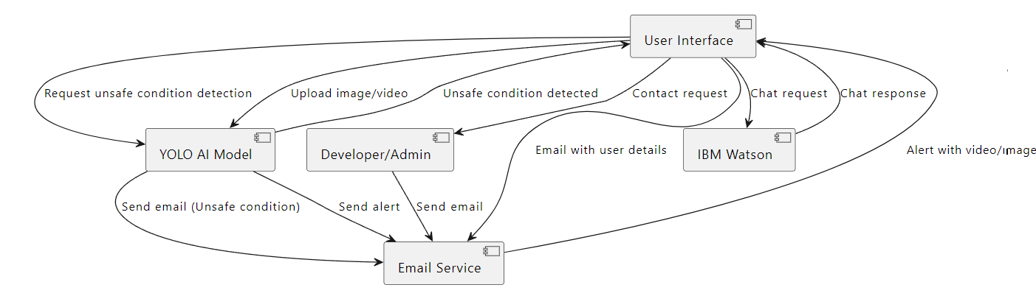

Here are some details about the components of the user flow diagram:

* User Interface: The user interface is the part of the system that the user interacts with. It allows the user to upload images or videos, request unsafe condition detection, and view the results of the detection.
* YOLO AI Model: The YOLO AI model is a computer vision model that can be used to detect objects in a frame. It is trained on a dataset of images that contain unsafe conditions.
* Developer/Admin: The developer or admin is responsible for managing the system. They can view the results of the detection, contact the user, and take corrective action.
* Email Service: The email service is used to send emails to the user with the details of the unsafe condition.

Here is a detailed explanation of each step which will take place after the user uploads Image or Video:

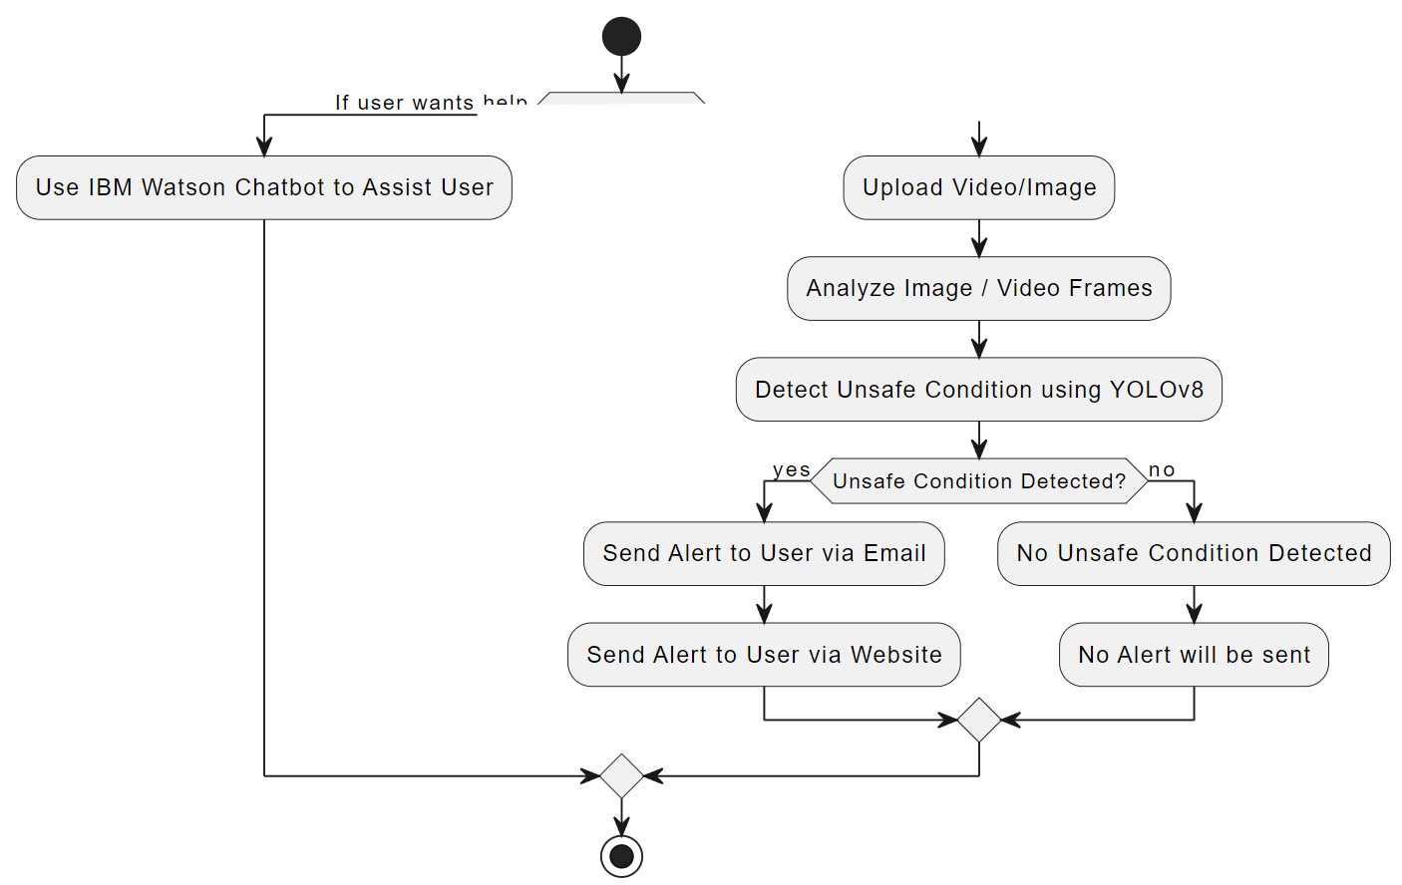

1. The user uploads an image or video to the system using a web browser or mobile app.
2. The system receives the image or video and stores it on a server.
3. The system then uses the YOLO AI model to analyze the image or video frame by frame.
4. The YOLO AI model is a computer vision model that is trained on a dataset of images that contain unsafe conditions. The model can identify different types of unsafe conditions, such as spills, leaks, and damaged equipment.
5. If the YOLO AI model detects an unsafe condition in any frame, it will flag that frame as unsafe.
6. The system will then send an alert to the developer or admin. The alert will include the details of the unsafe condition, such as the type of condition, the location of the condition, and the time the condition was detected.
7. The developer or admin can then view the unsafe frames and take corrective action. For example, they could contact the user to request more information or they could send a team to fix the problem.
8. If no unsafe conditions are detected, the system will not send an alert.

### 

## 6. RESULTS

This section presents the real-world application of the developed system, including screenshots that demonstrate its functionality and effectiveness in hazard detection and user interaction.

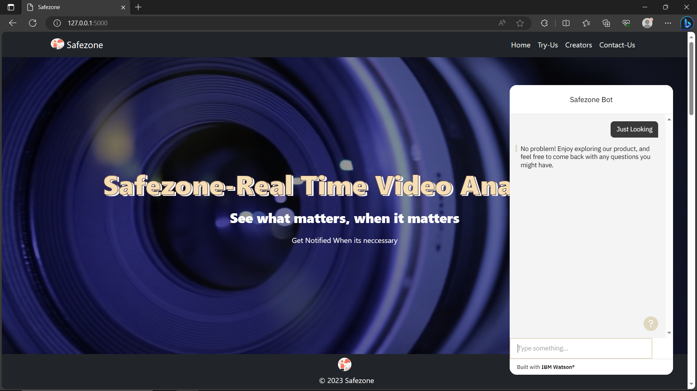

Landing page of our website: This image shows the name of our project and IBM Watson Chat bot at the lower right corner.

# 

This image shows position where the user can upload image or video for analysis in the web page. And then hit 'submit' button after the file is selected.

# 

This image shows that the video is being analysed by the AI model. In the right we can see that the AI has created a bounding box around the rifle.

# 

In this image we can see that an alert is shown on the top of the web page with a link containing small video or image which have been deem unsafe circumstance.

# ddfsfsdf

Email alert the user/admin will receive in case of potential security issue gets detected by our AI model.

# 7.ADVANTAGES & DISADVANTAGES

#### 7.1 Advantages

1. Real-time Hazard Detection: The system provides real-time detection of potential safety hazards, enabling immediate intervention to prevent accidents.
2. Multi-Class Detection: The YOLO model trained on different classes (weapon, fall, robber-mask, etc) to enhances the system's ability to identify different types of hazards accurately.
3. Proactive Alerting and Automated Reporting: The system generates automated alerts and emails containing attachments, simplifying the reporting process and reducing manual intervention. It ensures that relevant personnel are informed as soon as a hazard is detected.
4. Enhanced Industrial Safety: The system improves overall workplace safety by preventing unauthorized access, identifying dangerous tools, and providing timely assistance to fallen individuals.
5. User-Friendly Interface: The web interface allows users to easily upload images and videos, making hazard reporting and management accessible to non-technical personnel.
6. Chatbot Integration: IBM Watson Assistant enhances user engagement by providing real-time assistance and information through the chatbot interface.
7. Scalability: The modular architecture of the solution allows for easy scalability to accommodate more cameras and detection scenarios as needed.
8. Cost-Effective: By preventing accidents and minimizing workplace incidents, the system can lead to long-term cost savings due to reduced downtime and medical expenses.

#### 7.2 Disadvantages

1. **False Positives/Negatives:** The YOLO model might occasionally generate false positives (incorrect hazard alerts) or false negatives (missed hazards), leading to potential inefficiencies or overlooked hazards.
2. **Dependency on Internet:** The web app's functionality relies on a stable internet connection, which might be a limitation in areas with poor connectivity.
3. **Privacy Concerns:** Continuous video surveillance can raise privacy concerns among employees and visitors, requiring clear communication about the purpose and use of the system.
4. **Resource Intensive:** Running real-time video analytics and maintaining chatbot functionality can be resource-intensive, potentially impacting server performance.
5. **Skill Requirements:** The deployment and maintenance of the system might require technical expertise, which could be a challenge in environments with limited IT support.
6. **Initial Setup:** Setting up the system, integrating different technologies, and configuring the YOLO model can be complex and time-consuming.
7. **Sensitivity to Lighting and Conditions:** The accuracy of hazard detection might vary under different lighting conditions, weather, and camera perspectives.
8. **User Adoption:** Employees might need time to adjust to using the new system and interface, potentially affecting their willingness to participate.

## 8. APPLICATIONS

The SafeZone real-time video analytics web app, with its comprehensive hazard detection and prevention capabilities, finds utility across a range of industrial and safety-sensitive domains. Its ability to swiftly identify potential threats and proactively alert relevant stakeholders makes it a versatile solution for various applications:

1. **Industrial Facilities:** Enhance worker safety by detecting unauthorized access, weapons, and falls in real time.
2. **Construction Sites:** Ensure safety by identifying falls and unauthorized entry, enabling quick intervention.
3. **Warehouses:** Protect inventory and personnel by detecting unauthorized access, theft and potential threats.
4. **Transportation Hubs:** Bolster security by identifying suspicious behaviour and unauthorized access.
5. **Energy and Power Plants:** Maintain safety in high-risk environments by detecting falls and hazards.
6. **Mining Industry:** Prevent accidents by identifying hazards and unauthorized entry in mining sites.
7. **Healthcare Facilities:** Improve patient care by detecting falls and enabling timely medical response.
8. **Public Spaces:** Ensure safety during events by identifying potential threats and suspicious activities.
9. **Research Labs:** Prevent mishandling of hazardous materials by detecting unauthorized access.
10. **Retail Spaces:** Reduce theft and vandalism by identifying unusual activities.

The SafeZone solution's adaptability and versatility make it an indispensable tool across a spectrum of industries and settings, where safety and hazard prevention are paramount concerns. Its proactive approach to threat detection and immediate response empowers organizations to create safer and more secure environments for their workforce and assets.

## 9. CONCLUSION

The SafeZone real-time video analytics web app exemplifies the power of technology to enhance industrial safety. By seamlessly integrating Flask, YOLO model, IBM Watson Assistant, and more, the project has created a robust solution for real-time hazard detection.

Initial steps involved meticulous YOLO model training across critical classes: weapon detection, fall detection, and robber-mask detection. This foundation empowered the system to rapidly identify potential hazards in industrial settings.

The web interface's simplicity, backed by OpenCV and AI, enables users to submit media for hazard detection. IBM Watson Assistant's chatbot elevates user engagement, offering real-time support within the web app.

SafeZone's proactive identification of objects, activities, and behaviours facilitates accident prevention and rapid response. Immediate email alerts with attachments ensure swift notifications, enabling timely interventions.

In summary, SafeZone's impact extends beyond technology—it nurtures a safety culture across industries. While challenges like accuracy and privacy persist, the project's future lies in its adaptability and ability to embrace technological advancements.

The SafeZone project represents innovation with a purpose—to safeguard lives, assets, and industry progress. As we look forward, it epitomizes the potential of technology to transform industries and prioritize safety.

## 10. FUTURE SCOPE

The SafeZone real-time video analytics web app demonstrates significant potential for growth and enhancement. As technology continues to evolve and new possibilities emerge, there are several avenues to explore for the project's future development:

1. Improved Detection Accuracy: Continuously refining the YOLO model through additional training data and optimization techniques can enhance detection accuracy, reducing false positives and negatives.
2. Advanced Object Recognition: Expanding the model's capabilities to recognize more object classes can broaden the system's applicability, such as identifying specific tools or hazardous materials.
3. Integration of AI Enhancements: Incorporating advanced AI techniques like deep learning and reinforcement learning can enable the system to learn from its interactions and adapt to changing environments.
4. Real-time Analytics Dashboard: Developing a dashboard to visualize real-time analytics, including hazard trends and geographical distribution, can provide insights for proactive safety measures.
5. Multi-Camera Support: Enabling the system to handle inputs from multiple cameras can extend coverage across larger areas and complex layouts.
6. Edge Computing: Exploring edge computing solutions can reduce latency by processing some analytics on the camera devices, making real-time responses even faster.
7. Mobile App: Creating a mobile app companion to the web interface allows users to monitor and receive alerts on the go, enhancing accessibility and convenience.
8. Cloud Integration: Integrate with cloud platforms to enable scalable storage, backups, and remote access to data and alerts.
9. Environmental Adaptability: Enhancing the system's performance in different lighting conditions, weather scenarios, and environmental factors can improve its robustness.
10. Predictive Analytics: Utilize historical data to develop predictive models that anticipate potential hazards based on past trends and patterns.
11. Human Pose Detection: Adding human pose estimation can enhance fall detection accuracy by considering body positions during potential falls.
12. Ethical and Legal Considerations: Address privacy concerns by implementing features like anonymization of personnel and complying with relevant data protection regulations.
13. User Customization: Allow users to define their own detection rules and customize alert thresholds based on their specific needs.
14. Feedback Loop: Incorporate a mechanism for users to provide feedback on detection accuracy and system performance, enabling continuous improvement.

## 11. BIBLIOGRAPHY

During the course of developing the SafeZone project, a range of resources were consulted to shape its conception, design, and implementation. The following references have contributed to the theoretical foundation and practical realizaAmarender Katkamtion of the project:

1. Redmon, J., & Farhadi, A. (2018). YOLOv3: An Incremental Improvement. arXiv preprint arXiv:1804.02767.
   * This paper provides a deep insight into the YOLO model, the cornerstone of your real-time object detection capabilities.
2. OpenCV Documentation. (n.d.). OpenCV: Open Source Computer Vision Library. <https://docs.opencv.org/>
   * The official documentation for OpenCV, which guided your image and video processing tasks within the project.
3. Flask Documentation. (n.d.). Welcome to Flask. <https://flask.palletsprojects.com/en/2.1.x/>
   * The Flask documentation, essential for building your web application's backend and creating the user interface.
4. Bootstrap Documentation. (n.d.). Bootstrap.

<https://getbootstrap.com/>

* + Bootstrap's documentation, which helped you design a responsive and visually appealing user interface.

1. IBM Watson Assistant Documentation. (n.d.). IBM Watson Assistant. <https://cloud.ibm.com/docs/assistant>
   * The IBM Watson Assistant documentation, providing guidelines on integrating the chatbot feature into your application.
2. Dey, D. (2020). Flask Web Development with Python Tutorial. <https://youtu.be/dam0GPOAvVI>
   * This video tutorial guided you through the basics of Flask web development, helping you set up your project's foundation.
3. Zhang, L., Lin, L., Liang, X., He, K., & Sun, J. (2019). Is a Single Classifier Enough in Object Detection? arXiv preprint arXiv:1904.06405.
   * This paper discusses the effectiveness of single-stage object detectors like YOLO and their impact on real-time applications.
4. Watson, I. (2005). Implementing an IBM Watson Chatbot in Flask. <https://www.ibm.com/cloud/learn/watson-chatbot-flask>
   * A practical guide on implementing the IBM Watson chatbot, which contributed to the integration in your application.
5. Safezone Dataset.

<https://universe.roboflow.com/explore-mtqut/safezone>

* + The Safezone Dataset from Roboflow, was used for training the YOLOv8 Model.

## APPENDIX

### Source Code

The complete source code for the SafeZone project can be accessed at the following location:

[github.com/smartinternz02/SBSPS-Challenge-10608-SafeZone-Real-time-Video-Analytics-for-Industrial-Safety](https://github.com/smartinternz02/SBSPS-Challenge-10608-SafeZone-Real-time-Video-Analytics-for-Industrial-Safety)

Please refer to this repository for the detailed implementation of the project, including the Flask application, YOLO model integration, IBM Watson Assistant integration, and the email alert mechanism.